|  |  |  |
| --- | --- | --- |
|  |  | (1) |
| **Model1** |  | (2) |
|  |  | (3) |

|  |  |  |
| --- | --- | --- |
|  |  | (4) |
| **Model2** |  | (5) |
|  |  | (6) |
|  |  | (7) |

|  |  |  |
| --- | --- | --- |
|  |  | (8) |
| **Model3** |  | (9) |
|  |  | (10) |
|  |  | (11) |
|  |  | (12) |

|  |  |  |
| --- | --- | --- |
|  |  | (13) |
| **Model4** |  | (14) |
|  |  | (15) |
|  |  | (16) |
|  |  | (17) |



Figure 1

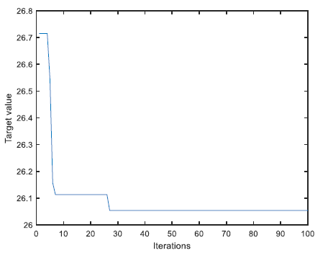

Figure 2



Figure 3